Amy Nestingen

DSC 640

9/10/2020

Week 1 and 2 Exercise

# Python

## Bar chart

Data Set: Hot Dog Winners

Title: Count of Hot Dog Winners by Country

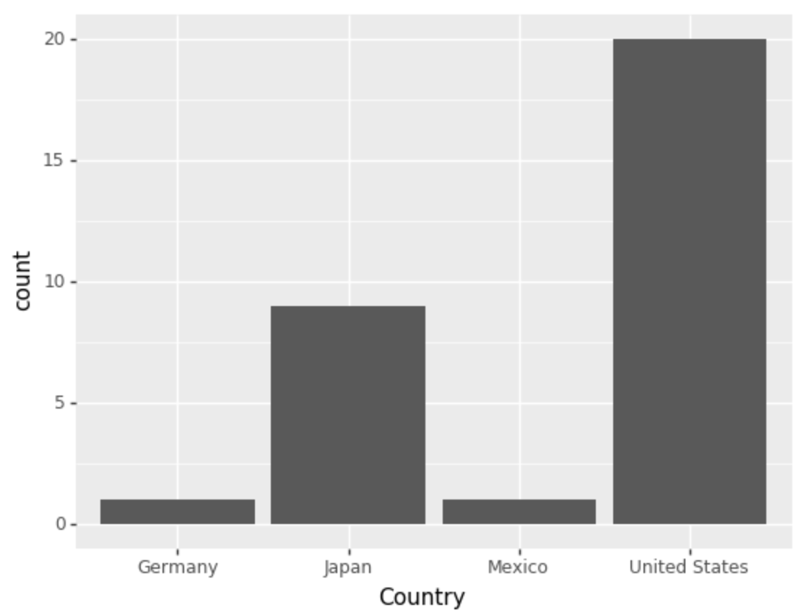

## Stacked Bar chart

Data Set: Obama Approval Rating

Title: Status of Approval Rating by Issue

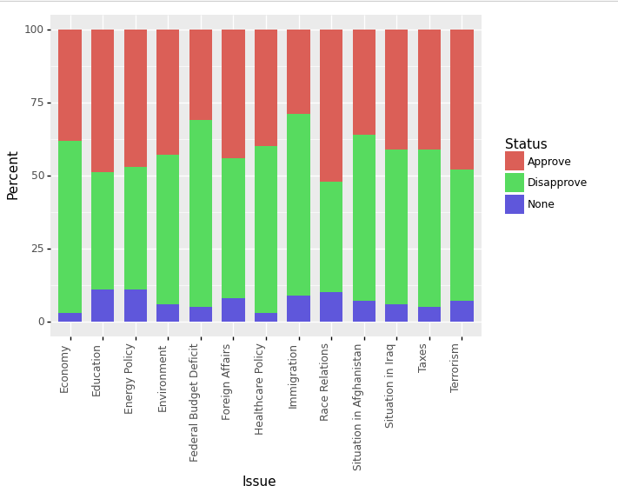

## Pie Chart

Data Set: Obama Approval Rating

Title: Approval Status for All Issues

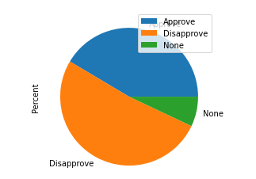

## Donut Chart

Data Set: Obama Approval Rating

Title: Approval Status for Education

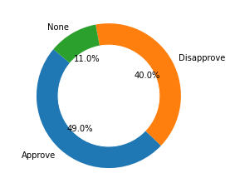

# R

## Bar chart

Data Set: Hot Dog Winners

Title: Count of Hot Dog Winners by Country

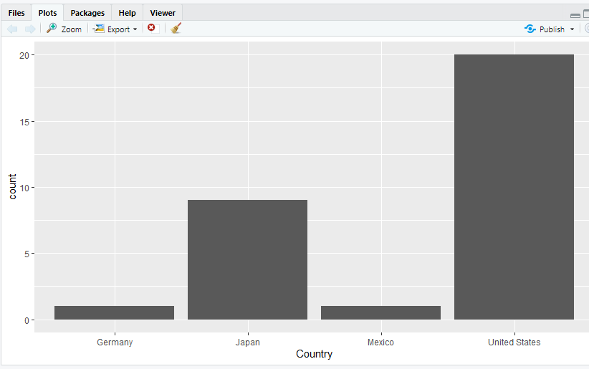

## Stacked Bar chart

Data Set: Obama Approval Rating

Title: Status of Approval Rating by Issue

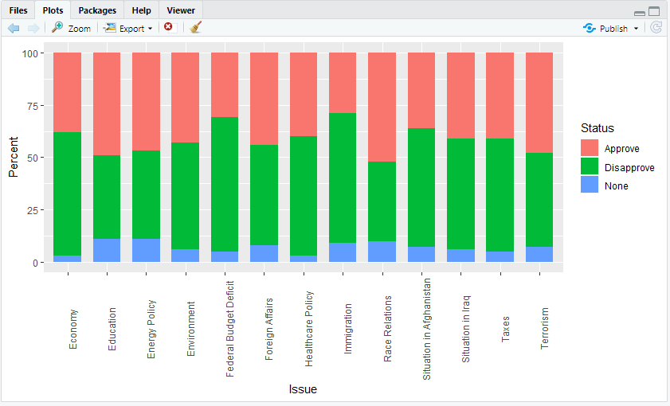

## Pie Chart

Data Set: Obama Approval Rating

Title: Approval Status for All Issues

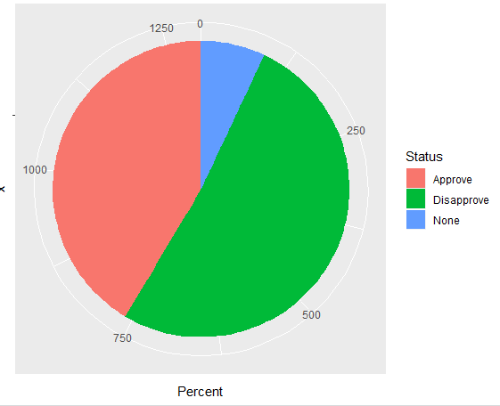

## Donut Chart

Data Set: Obama Approval Rating

Title: Approval Status for Education

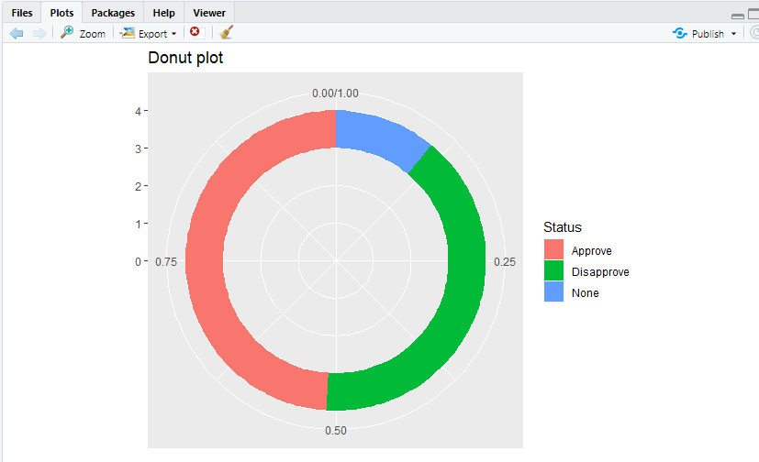

# Power BI

## Bar chart

Data Set: Hot Dog Winners

Title: Count of Hot Dog Winners by Country

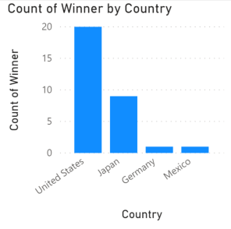

## Stacked Bar chart

Data Set: Obama Approval Rating

Title: Status of Approval Rating by Issue

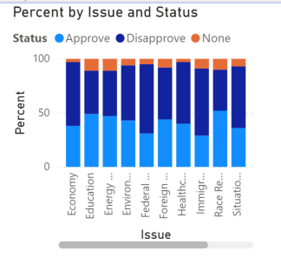

## Pie Chart

Data Set: Obama Approval Rating

Title: Approval Status for All Issues

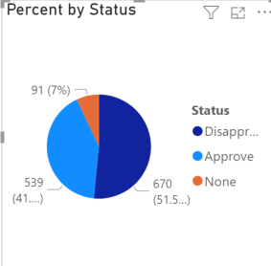

## Donut Chart

Data Set: Obama Approval Rating

Title: Approval Status for Education

